Task 001:

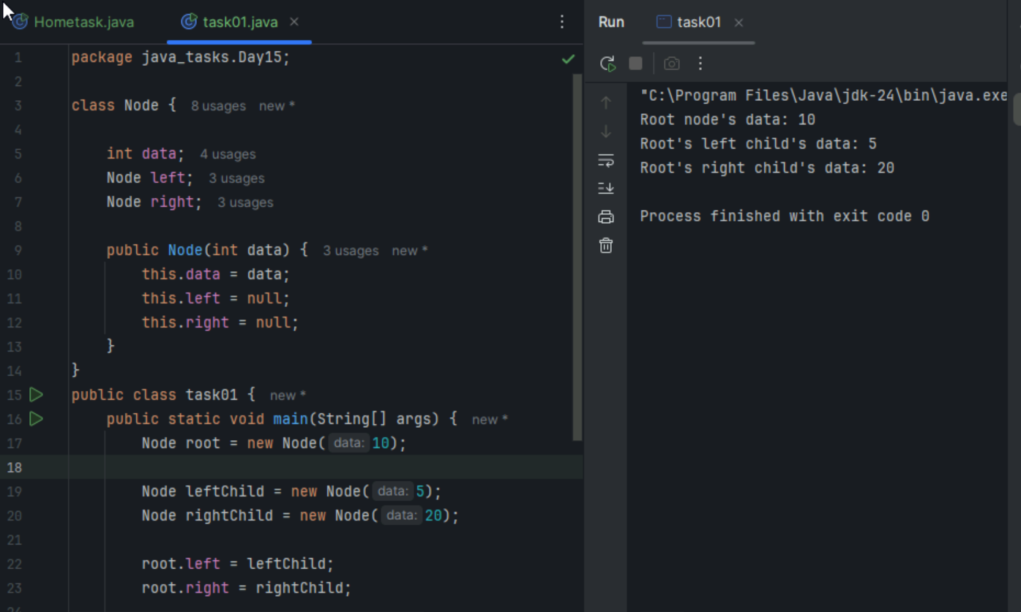

Task2:

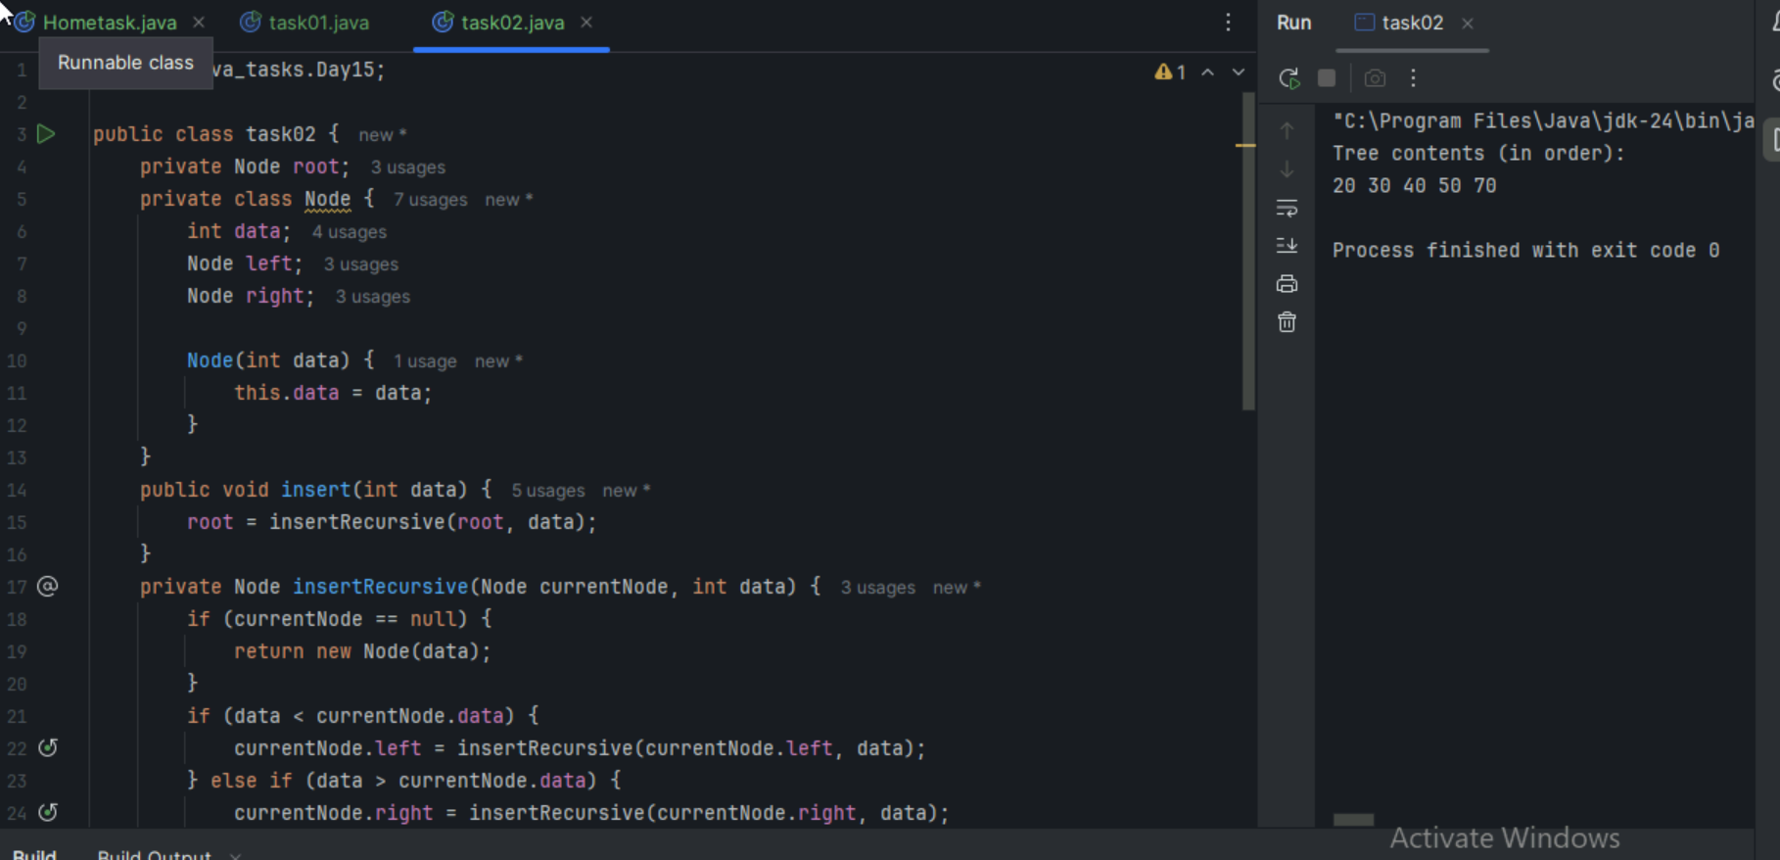

Task 03 a:

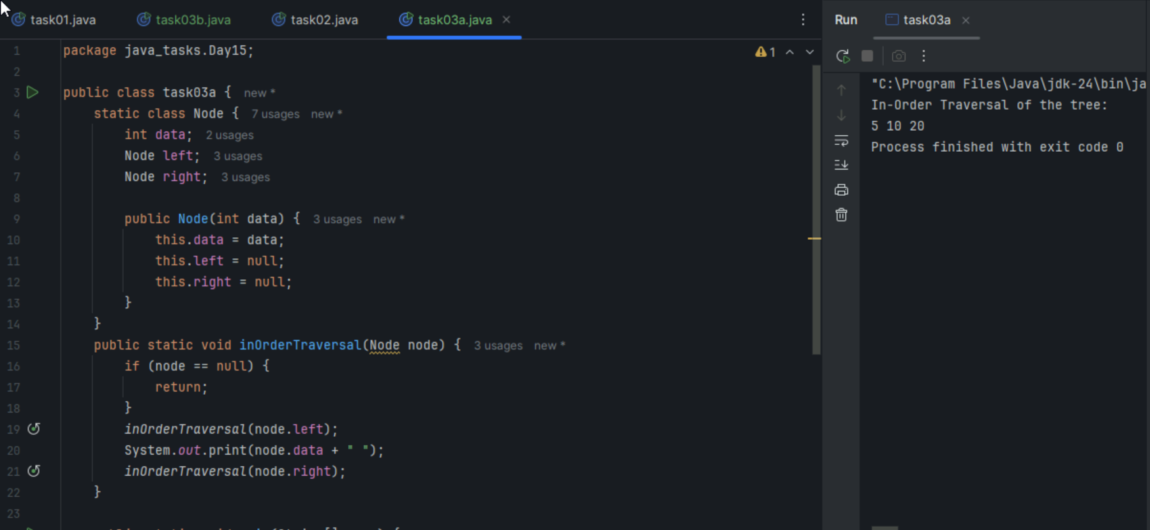

Task 03b:

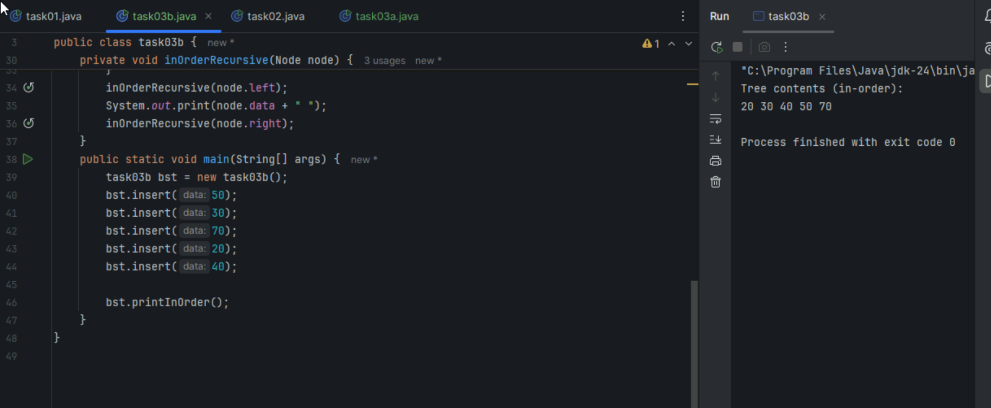

Task 04:

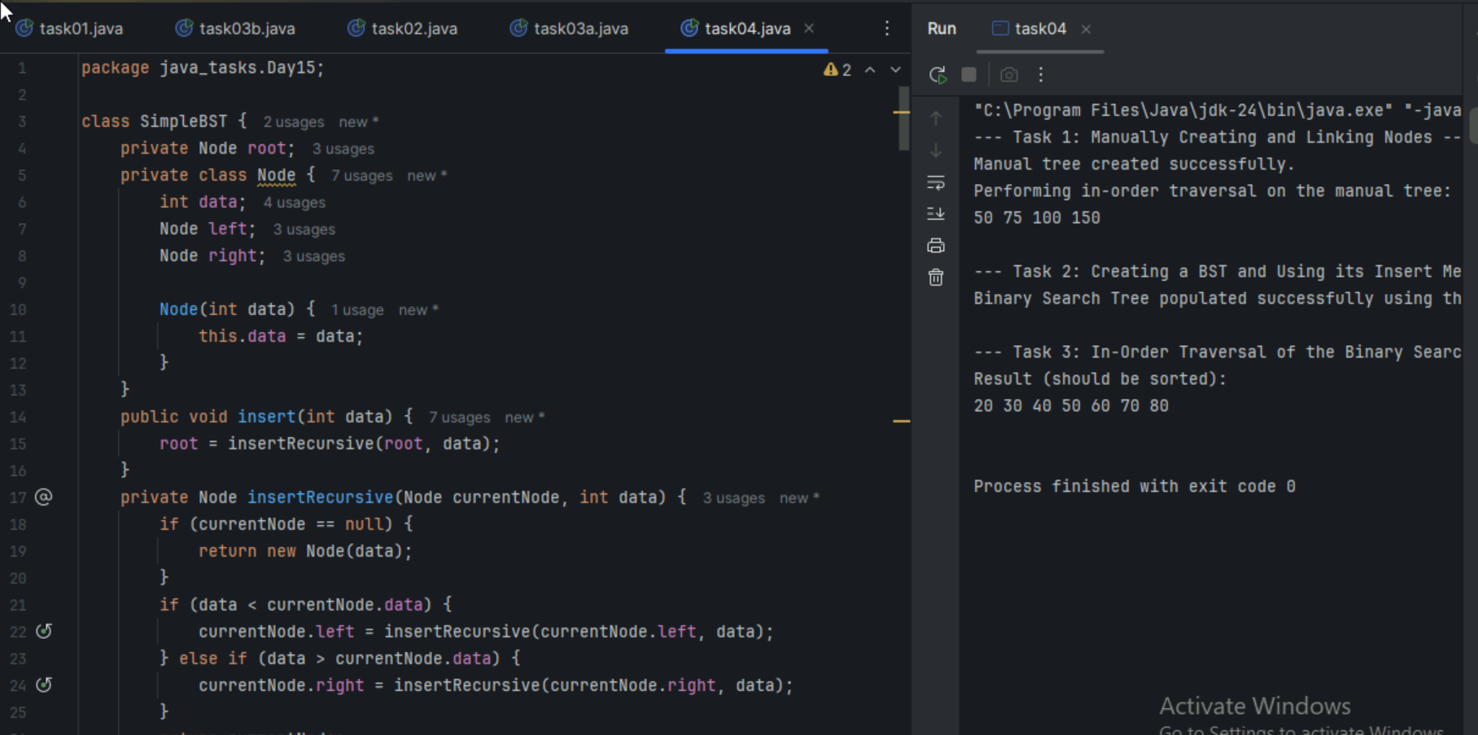

Task5:

Applications of trees:

Hierarchal data representation

Binary search

Syntax trees

Network routing algorithms and spanning trees

Decision making trees

Task6:

class TreeNode {

int item;

TreeNode left, right;

TreeNode(int item) {

this.item = item;

left = right = null;

}

}

class BinarySearchTreeOp02 {

TreeNode root;

public BinarySearchTreeOp02() {

this.root = null;

}

public void insert(int item) {

root = insertRec(root, item);

}

private TreeNode insertRec(TreeNode root, int item) {

if (root == null) {

root = new TreeNode(item);

return root;

}

if (item < root.item) {

root.left = insertRec(root.left, item);

} else if (item > root.item) {

root.right = insertRec(root.right, item);

}

return root;

}

public TreeNode search(int key) {

TreeNode current = root;

while (current != null) {

if (key == current.item) {

return current;

} else if (key < current.item) {

current = current.left;

} else {

current = current.right;

}

}

return null;

}

public void inorder() {

inorderRec(root);

System.out.println();

}

private void inorderRec(TreeNode root) {

if (root != null) {

inorderRec(root.left);

System.out.print(root.item + " ");

inorderRec(root.right);

}

}

public static void main(String[] args) {

BinarySearchTreeOp02 bst = new BinarySearchTreeOp02();

System.out.println("Inserting elements: 50, 30, 70, 20, 40, 60, 80");

bst.insert(50);

bst.insert(30);

bst.insert(70);

bst.insert(20);

bst.insert(40);

bst.insert(60);

bst.insert(80);

System.out.print("In-order traversal: ");

bst.inorder();

System.out.println("\nSearching for elements:");

int searchKey1 = 40;

TreeNode result1 = bst.search(searchKey1);

if (result1 != null) {

System.out.println("Found " + searchKey1 + " in the tree.");

} else {

System.out.println(searchKey1 + " not found in the tree.");

}

int searchKey2 = 99;

TreeNode result2 = bst.search(searchKey2);

if (result2 != null) {

System.out.println("Found " + searchKey2 + " in the tree.");

} else {

System.out.println(searchKey2 + " not found in the tree.");

}

}

}

Task7:

Full Binary tree

Complete Binary tree

Perfect Binary tree

Skewed Binary tree

Balanced Binary tree

Task8:

Social Networks

Mapping Navigation

Computer Networks

World Wide Web

Logistics and Supply chain

Scheduling

Resource allocation

Biology and genetics

Chemical structures

Task9:

Undirected graph

Directed graph

Weighted graph

Unweighted graphs

Cyclic Graph

Acyclic graph

Task10:

class Graph01 {

class Edge {

int src, dest;

}

int vertices, edges;

Edge[] edge;

Graph01(int vertices, int edges) {

this.vertices = vertices;

this.edges = edges;

edge = new Edge[edges];

for(int i = 0; i < edges; i++) {

edge[i] = new Edge();

}

}

public static void main(String[] args) {

int noVertices = 5;

int noEdges = 8;

Graph01 gObj = new Graph01(noVertices, noEdges);

gObj.edge[0].src = 1;

gObj.edge[0].dest = 2;

gObj.edge[1].src = 1;

gObj.edge[1].dest = 3;

gObj.edge[2].src = 1;

gObj.edge[2].dest = 4;

gObj.edge[3].src = 2;

gObj.edge[3].dest = 4;

gObj.edge[4].src = 2;

gObj.edge[4].dest = 5;

gObj.edge[5].src = 3;

gObj.edge[5].dest = 4;

gObj.edge[6].src = 3;

gObj.edge[6].dest = 5;

gObj.edge[7].src = 4;

gObj.edge[7].dest = 5;

for(int i =0; i < noEdges; i++) {

System.out.println(gObj.edge[i].src+ " - " + gObj.edge[i].dest);

}

}

}

